GGGE1155 COMPUTER IN EDUCATION
Assignment 2: Course / Learning Management System (CMS / LMS)

Course Coordinator: Dr. Fariza Khalid
Group Members:
Siti Shakirah Binti Sayadi (A152746)
Ivy Elmira anak Jeri (A156104)
Nur Shazana Binti M.Ibrahim (A156307)

Learning Management System (LMS) VS Course Management System (CMS)

LMS | CMS
Definition:  - A software application for administration, documentation, tracking, reporting and delivery of electronic education technology (also known as e-learning) education courses or training programme. | Definition:  - A collection of software tools providing an online environment for course interactions.
- Example: Smpweb (UKM), Myupsi (UPSI), e-Warga (UKM) | - Example : WebCT, Blackboard, Sakai
Characteristics:  - Can be used to create questionnaire, do evaluation, roster and attendance checking, reading and writing materials.  - A powerful tool for consulting companies that specialize in staffing and training, extension schools, and any corporation looking to get a better grasp on the continuing education of its workforce.  - Has download and upload materials features | Characteristics::  - Allow instructors to manage communication and the distribution of materials, assignments, grades and other aspects of instruction for their courses.  - Both teachers and learners can utilize and monitor the system  - Focuses on all aspects of teaching, learning, and teacher-student interaction
Components of LMS  - Rosters  - Management Control  - Component Management  - Multi Device Access  - Distributed instructor and student base  - Courses calendar  - Student Engagement  - Assessment and Testing  - Grading and Scoring | Components of CMS  - Class materials (Course syllabus and handouts)  - Posting of papers and assignments  - Gradebook  - Integrated email  - Chat tool  - Discussion board

Examples of Learning Management System:
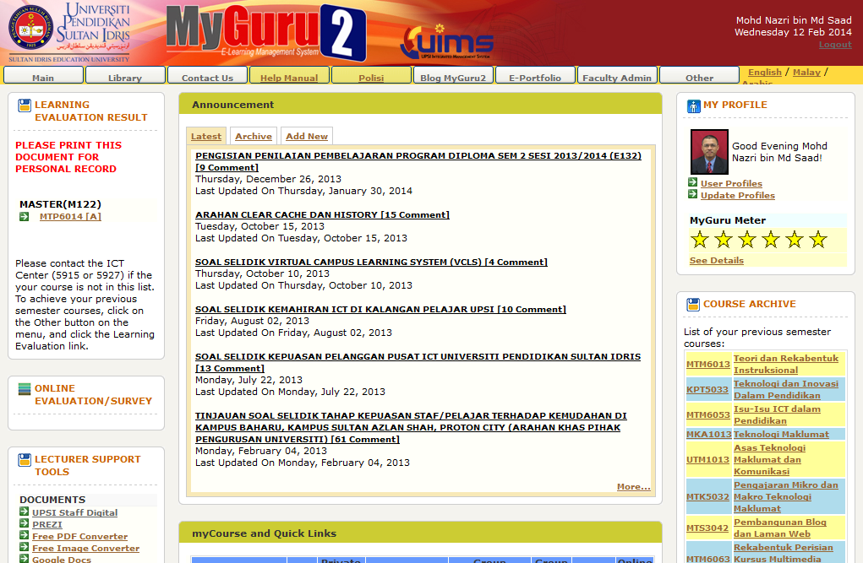
- MyGuru UPSI

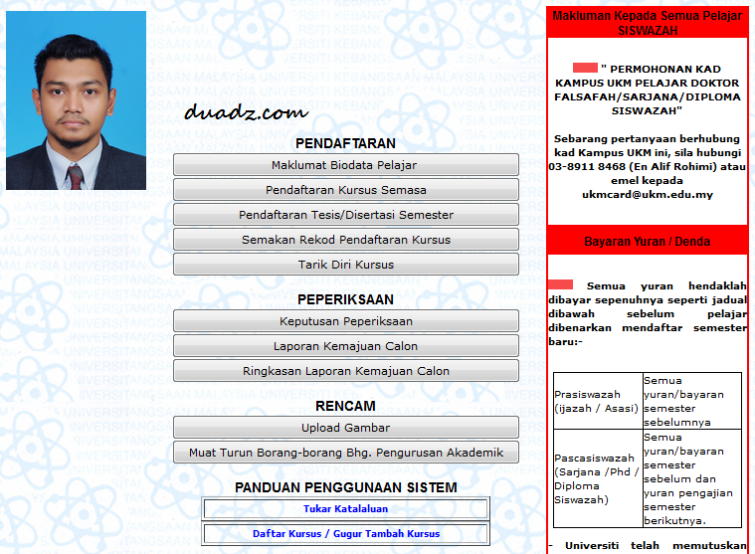

2)SMP WEB UKM

Examples of Course Management System:
- BlackBoard

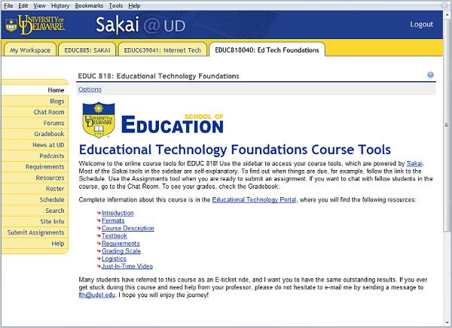
2) Sakai
Content Management System

Content management system is software tools that enable people to create, edit, publish, organize and review electronic text. This system is mainly for documentation. CMS is widely used for managing websites, which often contains news, blogs and shopping. There are two elements of CMS which vary between the basic concepts of user and content. Content management application (CMA) allows any user, who even has a limited knowledge to manage which includes add, modify, and remove content from a Website without needing the expertise of a Webmaster. On the other hand, content display application (CDA) gathers and utilizes that information and updates the Website. Thus, the major purpose of a Content Management System is to generate potential of various users with different permission levels to manage a website or a section of the content.

Most CMSs comprise Web-based publishing, format management, revision control, indexing, search and retrieval, however the features may differ. Web-based publishing provides a set of templates, wizards and other tools to allow user creates and modifies Web content. The format management formats any documents into Hypertext Markup Language (HTML) or Portable Document Format (PDF) for the Website. Next, revision control includes feature that updates as well as restores the content version to a previous one. It also tracks any alterations made to files by individuals. A user may find all data within organization that is indexed in a CMS system, search them using keywords which the CMS system retrieves. Typically, these features are applicable for many CMSs, but some also support the separation of content and presentation.

A website which has Articles, Blogs, Press Releases, Store, Events and assign each section or a part of a section to user to create, edit, and archive is an example of CMS, such as Google drive, Dropbox, and WordPress.

Examples of Content Management System:
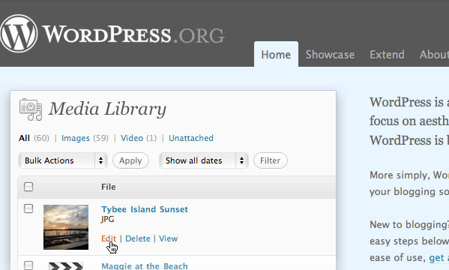
- WordPress

2) Drupal

References:
Course Management System. (2015). Retrieved from https://cft.vanderbilt.edu/guides-sub-pages/course-management-systems/
Definition of LMS. Retrieved from https://en.wikipedia.org/wiki/Learning_management_system#Characteristics

Definition and Characteristics. Retrieved from
file:///C:/Users/sis_kiera93/Downloads/MICRO_PAPER%20(4).pdf

Course Management System, Techopedia. (2010). Retrieved from https://www.techopedia.com/definition/6651/course-management-system-cms

Content management system (CMS) definition. Retrieved from
http://searchsoa.techtarget.com/definition/content-management-system

Stansberry, G. (2009). Top 10 Most Usable Content Management Systems. Retrieved from
http://code.tutsplus.com/articles/top-10-most-usable-content-management-systems--net-6493

